Creating JMeter Test Scripts for resources:

|  |  |  |  |  |  |  |  |  |  |  |  |  |  |  |  |  |  |  |  |  |  |  |  |  |  |  |  |  |  |  |  |  |  |  |  |  |  |  |  |  |  |  |  |  |  |  |  |  |
| --- | --- | --- | --- | --- | --- | --- | --- | --- | --- | --- | --- | --- | --- | --- | --- | --- | --- | --- | --- | --- | --- | --- | --- | --- | --- | --- | --- | --- | --- | --- | --- | --- | --- | --- | --- | --- | --- | --- | --- | --- | --- | --- | --- | --- | --- | --- | --- | --- |
| |  |  | | --- | --- | | GatewayIP | clinic-test.apigee.net | | GatewayPort |  | | GatewayProtocol | https | | executeTest | Y | | ACCESS_TOKEN_CONTEXT | oauth/token | | AccessToken | HTTP/1.1 200 OK | | clientID |  | | clientSecret |  | | scope | medicationdispense.read | | grantType | client_credentials | | accessTokenResponseMessage | access_token | | MEDICATIONDISPENSE_CONTEXT | /v2/MedicationDispense | | MEDICATIONDISPENSE_ID | 3423 | | MEDICATIONDISPENSE_TAGS | $meta | | MEDICATIONDISPENSE_HISTORY | _history | | MEDICATIONDISPENSE_SEARCH | _search | | MEDICATIONDISPENSE_VERSION | 1 | | _since | 2014-09-09T10:23:45 | | _count | 5 | | testName | MedicationDispense | | MEDICATIONDISPENSE | HTTP/1.1 200 OK | | authorizationHeader | Authorization | | languageValue | gvZHeYHUDT0ri3HWd-h0 | | COMPARTMENT | Patient | |

1. Variables Names:
2. Create Http Request default:
   1. Right click on Test -> Add -> Config Element -> Http Request Default
   2. Give any Name for Http Request
   3. In Server Name or IP -> ${GatewayIP}
   4. Implementation -> HttpClient4
   5. Protocol[http] -> ${GatewayProtocol}
3. Create HTTP header Manager:
   1. Right click on Test -> Add -> Config Element -> Http Header Manager
   2. Add header fields in Headers Stored in the Header Manager
4. Create a new Thread group for your resource e.g MedicationDispense
   1. Right click on Test -> Add -> Threads -> Thread group
   2. Right click on Thread group -> Add -> Config Element -> User defined variables
5. Create a Simple Controller (This is for the flow of your resource)
   1. Right click on Thread group -> Add -> Logic Controller -> Simple Controller
6. Create a Http request for above simple controller
   1. Right click on Simple controller -> Add -> Sampler -> Http Request
7. Add a Header manager for the above HTTP request
   1. Right click -> Add -> Config Element -> Header Manager
8. Create a response Code Assertion to make sure response fulfills certain criteria:
   1. Right click on simple controller -> Add -> Assertion -> Response Assertion
9. Create a Regular Expression extractor if you want to extract any specific data from response
   1. Right click on simple controller -> Add -> Post Processors -> Regular Expression Extractor
   2. Example below you can check how to extract access token from a response and set it to access_token variable.

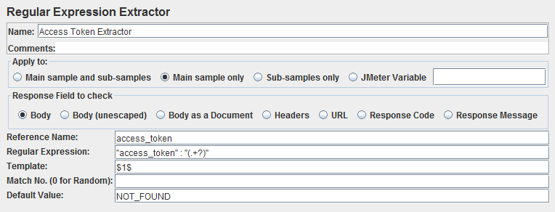

1. Create a result tree/table to see the result of requests
   1. Right click on Test -> Add -> Listeners -> View results tree
   2. Need to create two different trees for success and error